**HER POWER PROJECT**

**Training Category – Women Freelancer**

**SP-15, Sylhet Division**

| **SL No** | **Trainee’s Name** | **Mobile No** | **CT1**  **20 Marks** | **CT2**  **20 Marks** |
| --- | --- | --- | --- | --- |
| **1** | Shorif Noore Mansura | 01407676944 | **18** | **19** |
| **2** | Sadia Akter | 01772486753 | **15** | **18** |
| **3** | Umme Sanjida | 01743451081 | **18** | **19** |
| **4** | Sanchita Das Mithila | 0131463226 | **19** | **20** |
| **5** | Rejwana Jebin | 01925205214 |  |  |
| **6** | Sadeka Sultana Tahera | 01941302021 | **18** | **18** |
| **7** | Madhury Talukder | 01778075237 | **13** | **15** |
| **8** | Mourin Akter | 01314741342 | **16** | **19** |
| **9** | Tania Begum | 01324467587 |  |  |
| **10** | Mohima Akter Mahbuba | 01707653699 | **16** | **18** |
| **11** | Fahmida Jahan Choudhury | 01312847099 |  |  |
| **12** | Umme Nujhat Tabassum | 01302774616 | **14** | **16** |
| **13** | Marufa Hasan Tania | 01331269631 | **7** |  |
| **14** | Ripa Rani Das | 01795879094 | **16** | **15** |
| **15** | Nusrat Haque Noshin | 01946698281 | **16** | **15** |
| **16** | Ruji Akter | 01404689119 |  |  |
| **17** | Sumona Akter Chadni | 01315815493 | **14** | **16** |
| **18** | Sujeda Akter | 01795889614 |  |  |
| **19** | Sajeda Begum | 01309590703 | **17** |  |
| **20** | Rounok Jahan Shiwly | 01765192625 |  |  |

**Batch No:** SUN-SAD-WD-BATCH-01  **Upazila –** Sunamganj Sadar

**CT 1 Date:** 01-07-2024

**CT 2 Date:**

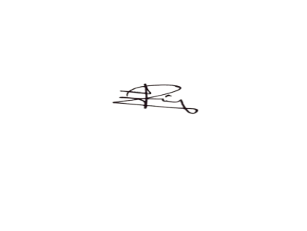**Trainers Sign : Authorized By: **